**NAAN MUDHAVAN**

**ASSIGNMENT DOCUMENT**

**COURSE TITLE** : DIGITAL MARKETING

**COLLEGE CODE** : 1105

**COLLEGE NAME** : GOJAN SCHOOL OF BUSINESS AND TECHNOLOGY

**NM ID** : 4CEAE4B73A74B698D5F41855BEFCF125

**NAME** : SANTHOSH H

**REGISTER NUMBER** : 110520106018

**YEAR** : 4TH YEAR

**DEPARTMENT** : ELECTRONICS AND COMMUNICATION ENGINEERING

1. Create a blog or website using Blogspot and Wordpress. Customize the theme design and post new article with 500 words.

Link: <https://www.blogger.com/blog/posts/243228541654359185>

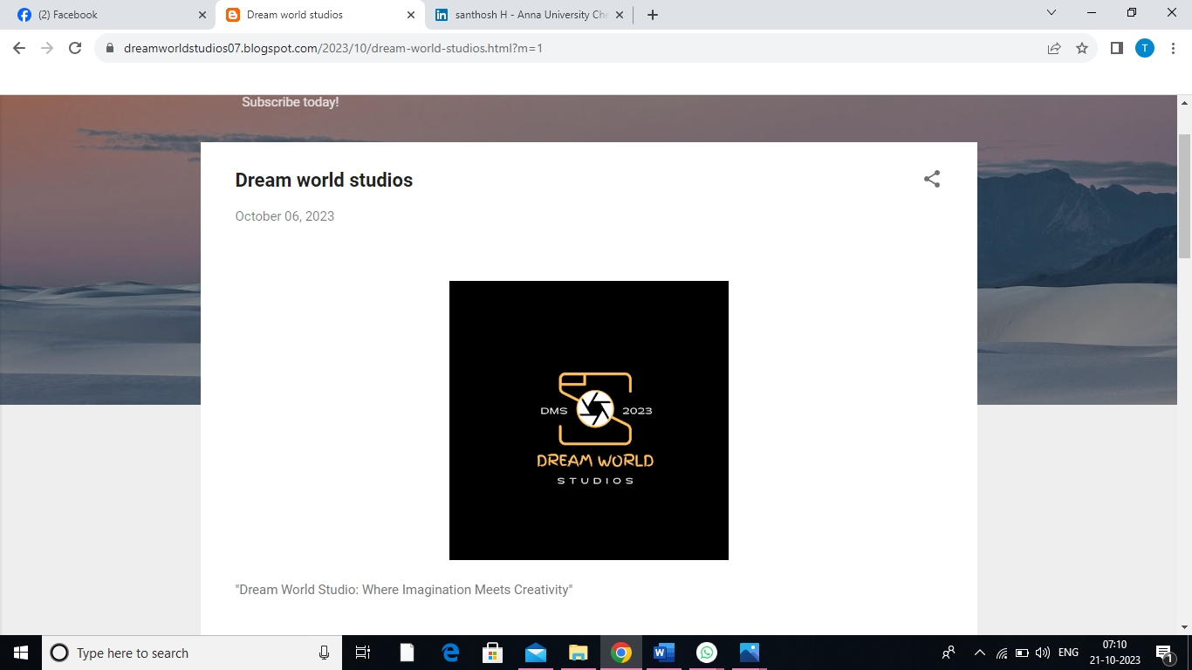

**"Dream World Studio: Where Imagination Meets Creativity"**

**Welcome to Dream World Studio, your passport to a realm where imagination knows no bounds and creativity takes center stage. Our studio is a haven for artists, creators, and dreamers of all kinds, where your visions and ideas come to life in the most enchanting and innovative ways.**

**\*\*Discover What Awaits You:\*\***

**1. **Creative Workspaces:** Immerse yourself in an environment designed to fuel your creative spirit. Our studio offers spacious and inspiring workspaces equipped with cutting-edge tools and technology to bring your ideas to fruition.**

**2. **Artistic Collaborations:** Connect with fellow creators and artists from diverse backgrounds. Collaborate on projects that blend talents and perspectives, resulting in unique and captivating creations.**

**3. **State-of-the-Art Facilities:** Explore our state-of-the-art facilities, including recording studios, production rooms, and photography studios, all designed to support a wide range of artistic endeavors.**

**4. **Workshops and Masterclasses:** Hone your skills and expand your creative horizons with our workshops and masterclasses led by industry experts. From painting and music composition to digital design and filmmaking, there's always something new to learn.**

**5. **Exhibition Spaces:** Showcase your work in our exhibition spaces, where you can share your creations with a broader audience. Whether it's visual art, music, or multimedia, we provide platforms for your talent to shine.**

**6. **Creative Retreats:** Join us for creative retreats and getaways that allow you to escape the everyday hustle and immerse yourself in an atmosphere of inspiration and innovation.**

**7. **Community and Networking:** Connect with like-minded individuals who share your passion for creativity. Our vibrant community is a source of support, encouragement, and endless possibilities.**

**At Dream World Studio, we believe that every dream deserves to be realized. Whether you're an artist, musician, filmmaker, designer, or simply someone with a desire to create, our studio is your canvas. Step into a world where the ordinary transforms into the extraordinary, and where your imagination finds its true home.**

**Join us on this incredible journey of artistic exploration and innovation. Subscribe to Dream World Studio today and unlock the door to a world where your dreams become a vibrant reality.**

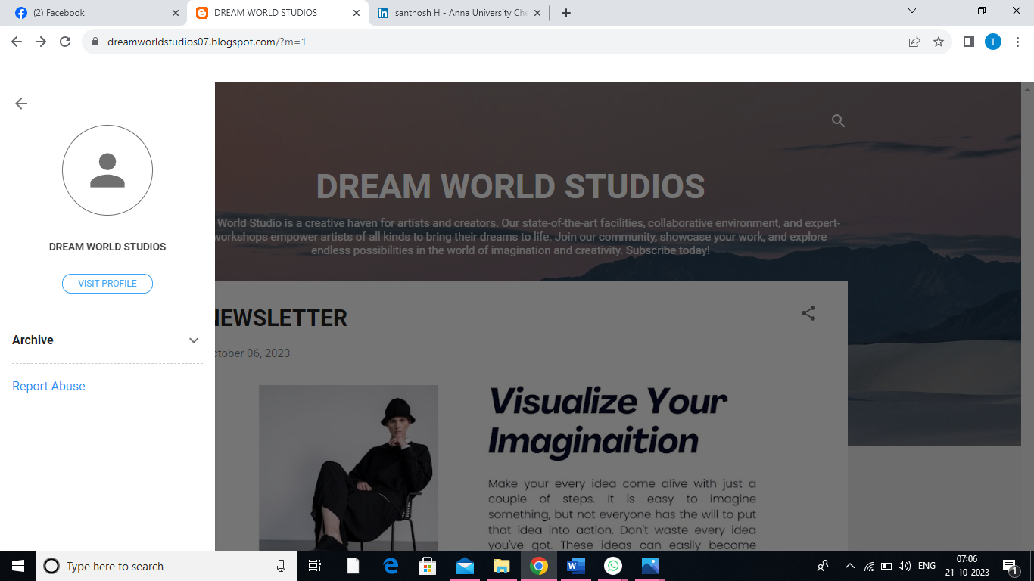

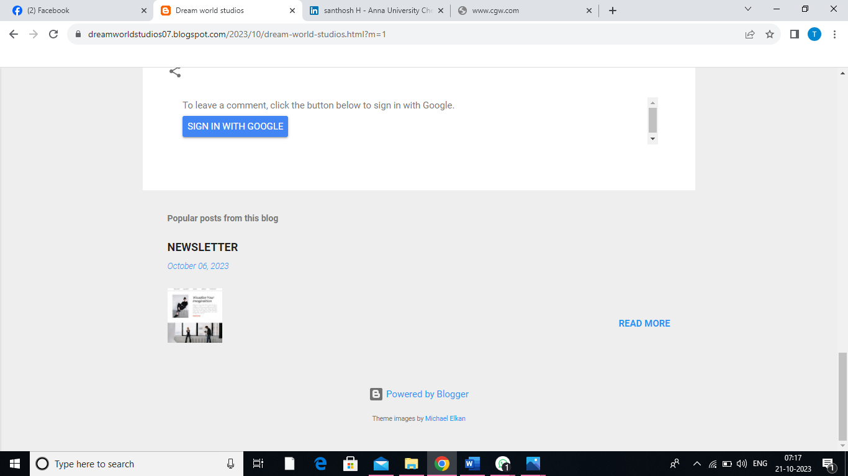

1. Create a New Facebook Business Page and post one social media poster for your brand.

Link: <https://www.facebook.com/profile.php?id=61551896501987>

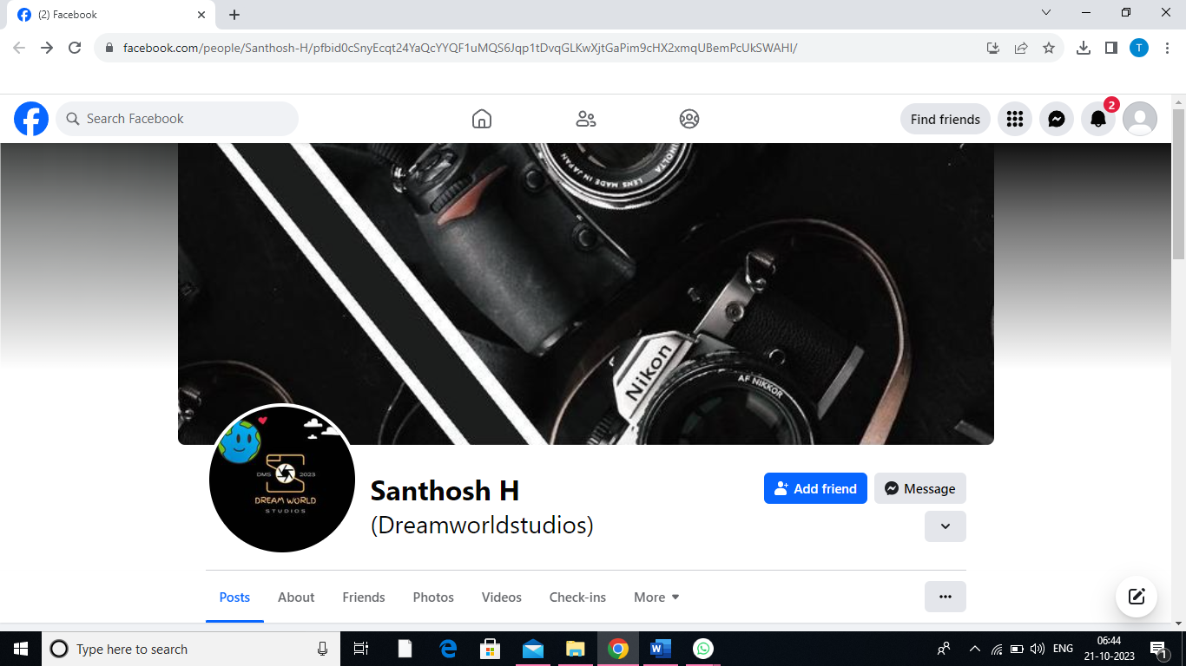

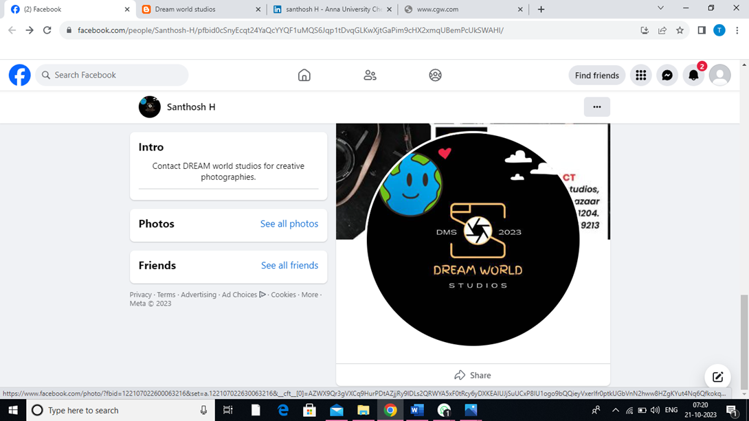

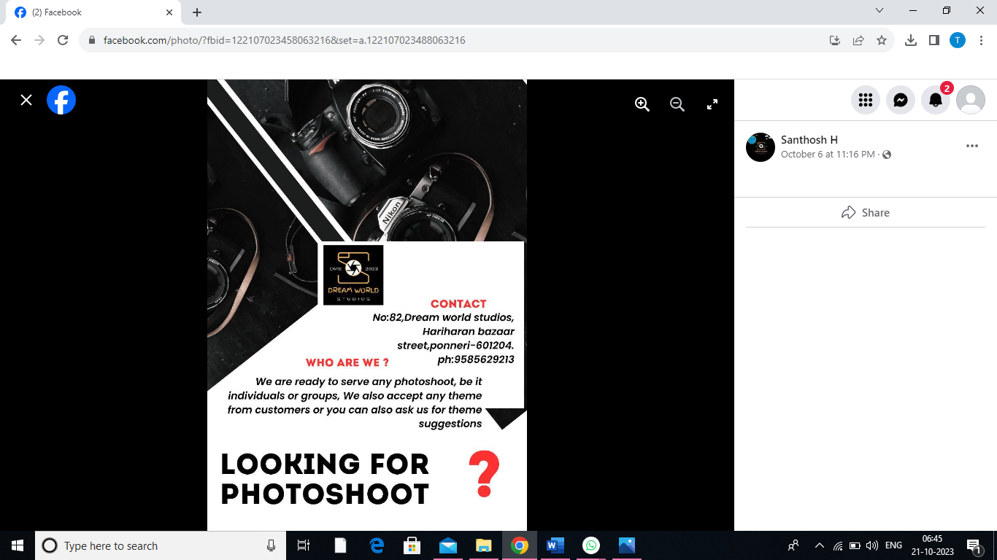

1. Create and design a social media advertisement poster using canva.

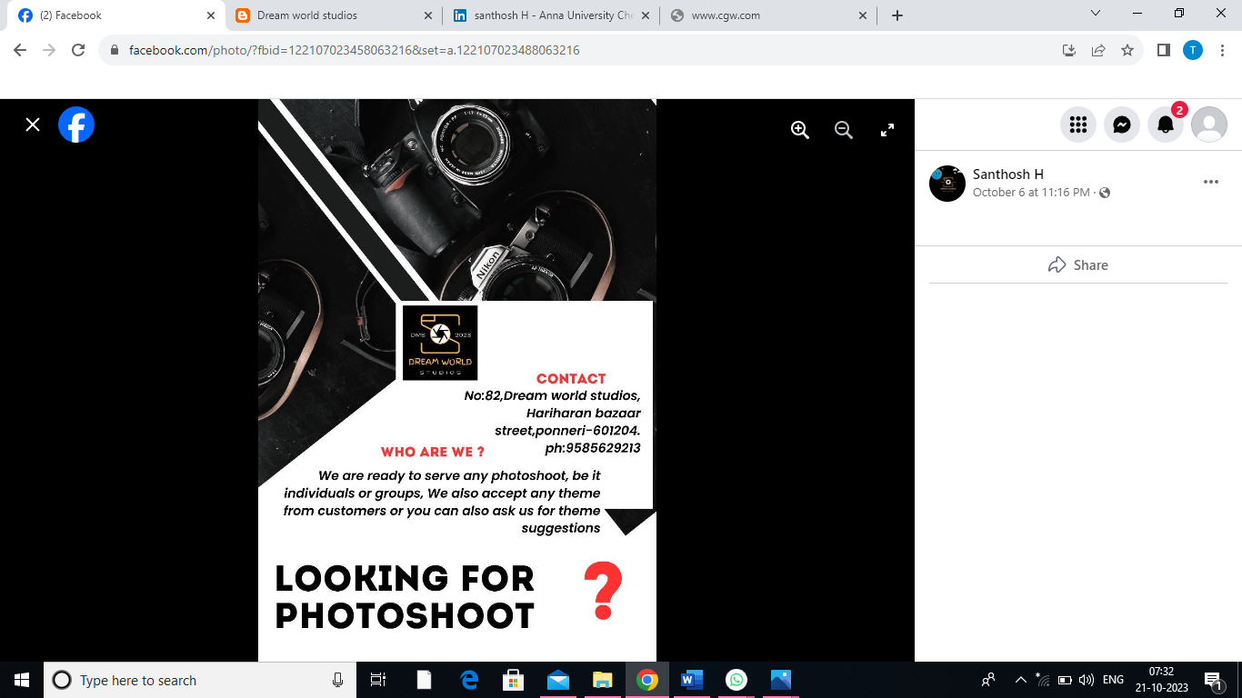

4.Create email newsletter design using MailChimp or canva tool.

Link: <https://dreamworldstudios07.blogspot.com/2023/10/newsletter.html?m=1>

